***Guidebook For Au Pairs***

***2016***

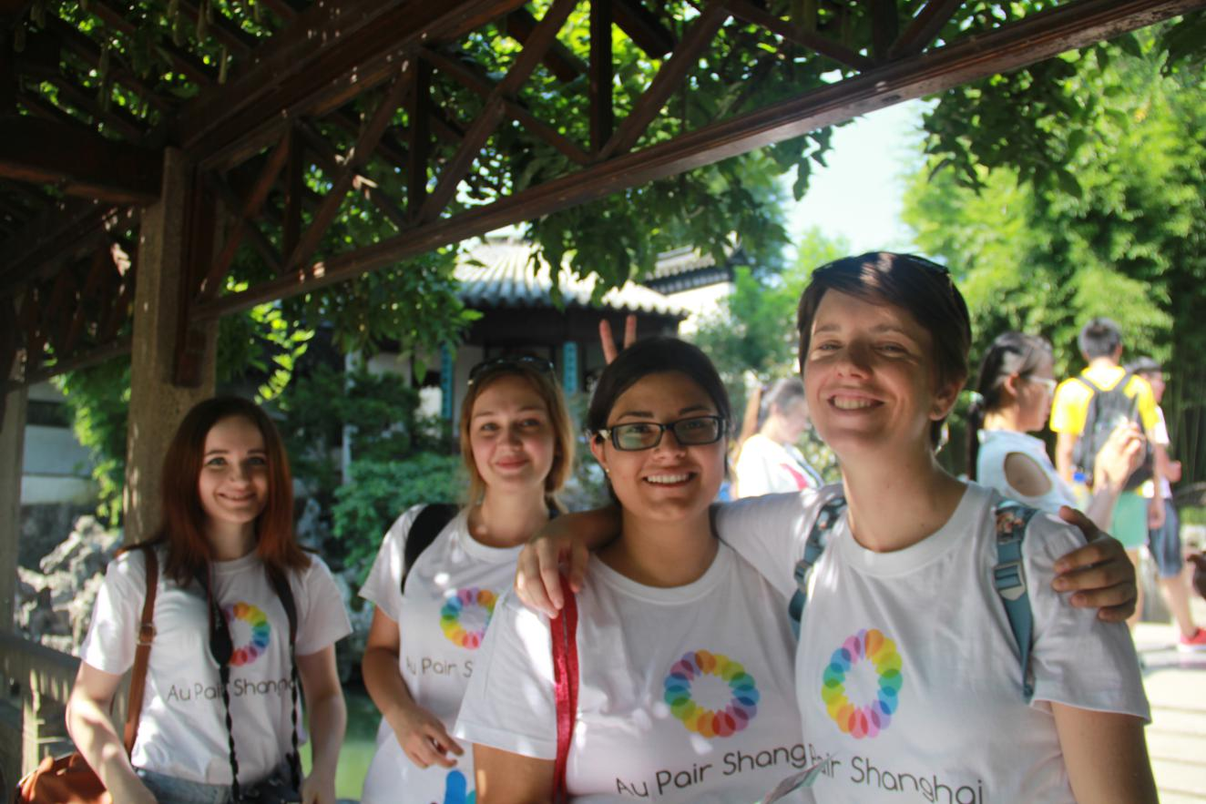

**Our official websites**:

[www.nihaoaupair.com](http://www.nihaoaupair.com)

[www.culturalpair.com](http://www.culturalpair.com)

**Table of Contents**

**I. Introduction to Au Pair Shanghai……………………………………………….3**

II. Au Pair Program in China 5

1. Requirements: ……………………………………………………………………………….6

III. Au Pair work in China 6

1. Benefits of Being an Au Pair in China……………………………………………….6

A. Job Outline: 6

B. Learning Chinese: 7

C. Social Outings: ..7

2. Au Pairs Will Be Supported By The Host Family...................................8

A. Insurance: 9

IV. Host Families in China 9

1. Locations & Accommodations 9

V. Application Process (For Au Pairs) 11

1. How Can You Apply？ 11

VI. Successful Cases/Testimonials 12

VII. F.A.Q.’s 13

VII. Contact Us...........................................................................................15

**I. Introduction to Au Pair Shanghai**

China is a country with a rich culture and history, and it is fast becoming a top travel destination choice. Until the 1980s, China was virtually closed off from the outside world, but now it is one of the largest economic world powers. China is now putting itself in the world spotlight by hosting world-famous events, such as the Olympic Games and 2010 World Expo.

After joining the World Trade Organization, we have witnessed a rapid and great economic growth. Language has gained a new and extreme socioeconomic importance in China. In this case, mastering a foreign language became essential, which helped create the necessity of the Au Pair Project. As an au pair, it will become vital for you to fulfill the host family’s need to create this foreign language environment for their family and compete with this new, vital social construct emerging in Chinese society.

Our center is based in Room 11G, Huamin Empire Plaza, Yan’an west road No. 728, Changning district, Shanghai. We focus on the development and promotion of Eastern-Western cultural exchange by supporting cross-culture communication and helping people to understand their differences.

Au Pair Shanghai is an agency, specialized in au pair programs, aimed to create opportunities for young people to visit and to learn about different countries in order to help them have a better understanding of the people, the history, and the culture of these countriesas well asto improve their language proficiency. We are pleased to work with foreign au pairs based in China mainly the foreigner applicants willing to be Au Pair in China and create the brand-new foreign language environment for the Chinese families since childhood.

Since our establishment in December of 2009, we have successfully matched more than 200 families and programs earned a very good reputation for providing the best service in China. We carefully research the families that will be the more suitable for you, pay close attention to these families and make sure they provide you both of the best working experience and cultural exchange possible.

If your dream is to learn about a new culture, improve your language proficiency and work in a new country, this could be the greatest experience of your life. Become an au pair and come to China!

***Do you want to join us?***

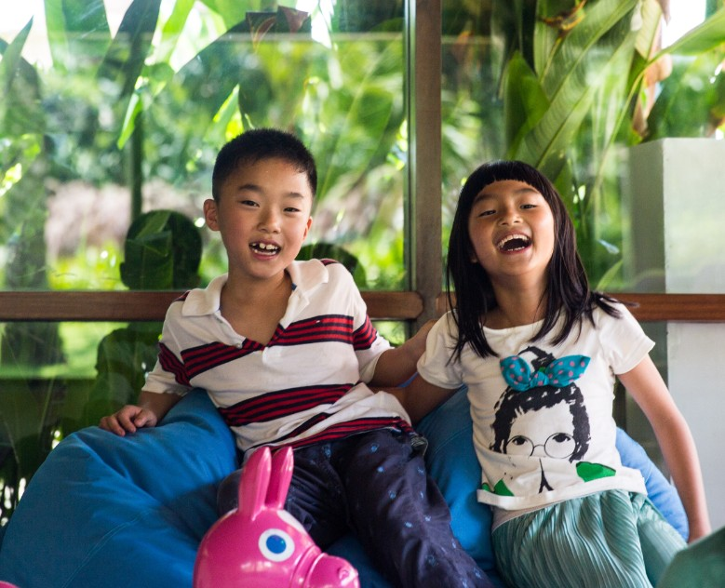

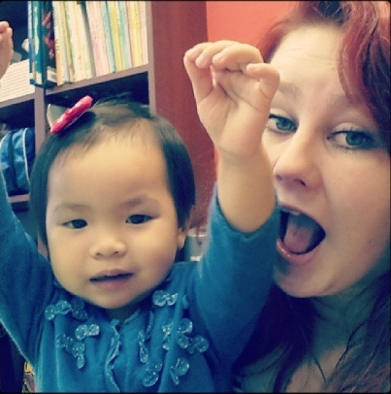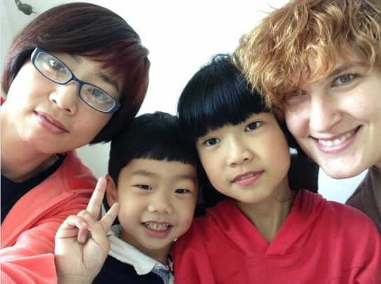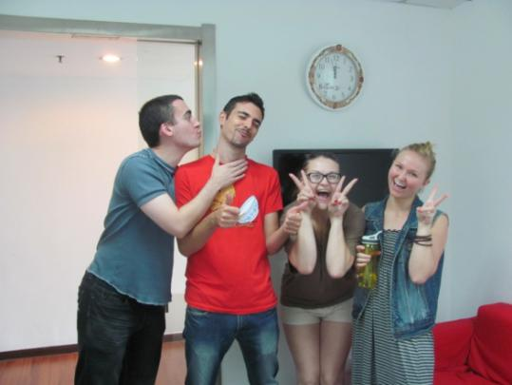

# 

# II. Au Pair Program in China

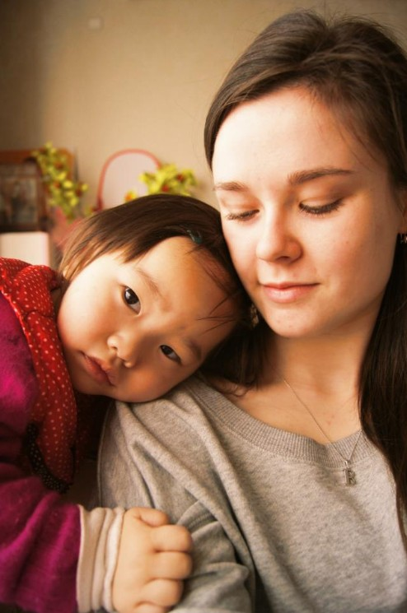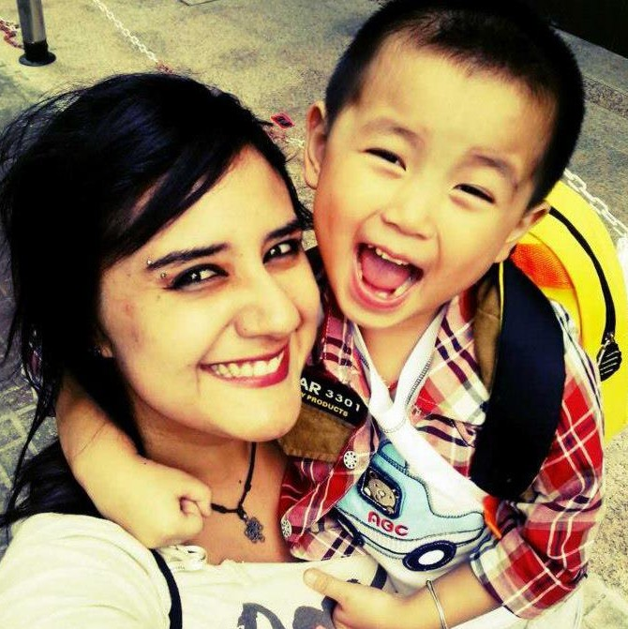

Work as an Au pair in China and experience a new culture and language, while working with children. This unique Au Pair Program gives you the opportunity to immerse yourself in Chinese culture, work with children and teach them English, and improve your Chinese language skills in China!

Au pair candidates are adventurous, curious, and interested in learning about new countries and cultures. They have a mature, independent, and positive nature. Most importantly, they love children and enjoy spending time with them.

The Au Pair Program in China will place you in a Chinese host family that is interested in giving their children, not only an education in English, but also a direct cultural education. You will have the opportunity to look at the host family profiles and decide on a host family before your departure.

## 1. Requirements:

● Age: 18 – 29 years old

● Language：Every language is acceptable, but families might prefer applicants from native English-speaking or European countries, such as Germany, France, Spain, and Italy.

● Minimum Educational Background：High school or above.

● Personality/Attitude: Mature, independent, likes children, positive, outgoing, and energetic.

● You must have a clean criminal record and a bill of good health.

●You can apply for a stay of 3 months/6 months/9 months/12 months in China.

# III. Au Pair work in China

## 1. Benefits of Being an Au Pair in China

1. Cultural exchange.
2. Learning Chinese with the host family or in a class held at Au Pair Shanghai.
3. Sharing different lifestyles, ways of thinking, manners, and living habits with the host family members.
4. Learning Chinese history and traveling to famous cities with the host family or Chinese friends in order to open your eyes to the splendor of Chinese.
5. Learning how to cook Chinese food.

A. Job Outline:

You will be expected to spend 30 hours per week as an au pair taking care of their children, escorting them to school, playing with and teaching them, etc. In addition, most families treat their au pair as a member of the family, so you might be invited to family holidays and gatherings!

B. Learning Chinese:

As part of the Au Pair in China Program, you will have at least 4 hours of Chinese classes per week. Your Chinese should improve rapidly since we have great teachers and the ratio of students is so low that it is almost private!

C. Social Outings:

We design various social outings, so that you will have the opportunity to meet other au pairs. There are also organized trips to see local sites and explore the area.

|  |  |
| --- | --- |
| Housework | * Clean and dust. * Wash and fold laundry. * Assist with shopping. * Clean the dishes (depends on the host family). |
| Childcare | * Responsible for assisting the children with their daily activities, such as dressing them, washing, brushing their teeth, eating lunch, bathing, etc. * Responsible for picking up the children from school. * Responsible for helping children do their homework. * Responsible for accompanying children when they play, such as indoor and outdoor games, telling stories, singing songs etc. * Responsible for organizing the children’s room and toys. |
| Cultural Communication | * Cultural exchange. * Learn Chinese. * Discuss cultural differences between China and Western countries with the host family members. * Cook alongside members of the host family. * Play sports, travel, and participate in family gatherings. |

**2.Au Pairs Will Be Supported By The Host Family**

|  |  |  |  |  |  |  |  |  |  |
| --- | --- | --- | --- | --- | --- | --- | --- | --- | --- |
| Length of Stay | | 3 Months | | 6 Months | | 9 Months | | 12 Months | |
| Insurance | | All of the insurance will be paid for by us. | | | | | | | |
| Airline Ticket Support | | 2000CNY | | 4000CNY | | 6000CNY | | 8000CNY | |
| Mandarin Classes | | No less than 4 hours per week. | | | | | | | |
| Visa Service | | All visa fees will be covered by us. | | | | | | | |
| Pocket Money | | 1500CNY at least per month. | | | | | | | |
| Au Pair Certificate | | Au Pair Shanghai awards a certificate to every au pair that finishes their whole period of time in China. | | | | | | | |
| **Remarks**: |  | |  | |  | |  | |  | |
| * Insurance will be paid by Au Pair Shanghai (A.P.S.H.) when the au pair first arrives in China. | | | | | | | | | | |
| * We provide you flight ticket support when you have finished your au pair period. | | | | | | | | | | |
| We will reimburse the visa cost after you finish your duration as an au pair in China.   * + Please send visa application receipt to us; all of visa extension cost will be covered by Au Pair Shanghai. * The au pair’s pocket money will be paid for by their host family –a garaunteed minimum of 1,500CNY every month. * Combined Au Pair & Tutor Program for English Native Au Pairs:   + Native English-speaking au pairs will have the opportunity to supplement their pocket money by a possible $451 usd every month in our Combined Au Pair & Tutor Program. Au pairs can work extra hours as a part-time, English tutor in addition to their au pair work in order to earn extra money. | | | | | | | | | | |

### A. Insurance:

* Accident Insurance: 530,000 Yuan
* Hospitalization & Medical Treatment Expense Insurance(Accidental): 29,000 Yuan
* Hospitalization Allowance: 300 Yuan Per Day(Accidental)
* Hospitalization & Medical Treatment Expense Insurance(Disease)
* Hospitalization allowance: 50 Yuan Per Day

# Iv. Host Families in China

You can make it happen by living as part of a Chinese host family for a whole year through Au Pair Shanghai. You will help take care of your host family's children and teach them English in exchange for the experience of living as a respected "big sister" or "big brother" in a Chinese family.

## 1. Locations & Accommodations

* 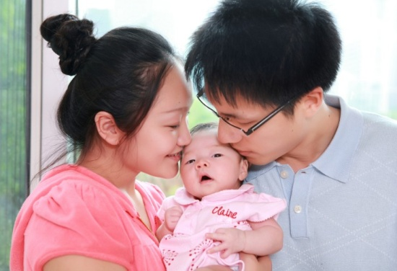Chinese families usually live in apartments in cities.
* In most cases, a private room is provided.
* Wireless internet is provided.
* Children’s ages can range from 0-18 years old.
* Free meals.

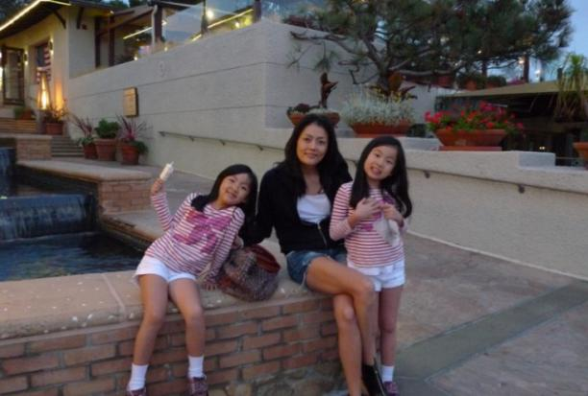

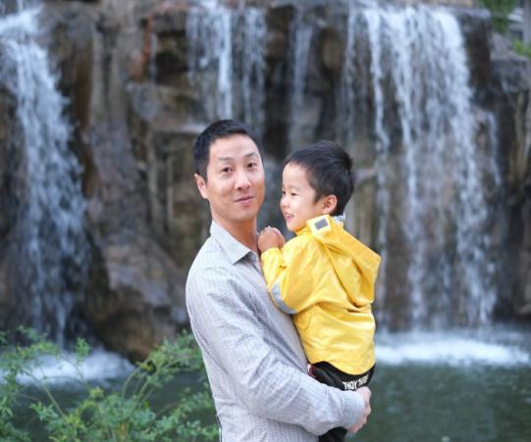

**Dear Au Pair,**

I am glad that you can become one of our family members, and I am looking forward to welcoming you; however, I also would like to emphasize the importance of this opportunity for cultural exchange.

Our family has 4 members. The father works at chemical company in Jiangsu and has flexible working hours; he likes to swim nearly every day. He is an easy-going person with a strong communication ability. I work in Shanghai as a financial manager for a trading company. I work every day from 9:30 A.M. to 6:00 P.M., and I like dancing and playing badminton.

Our eldest son is 13 years old; he studies at the Yangbo School in Zhabei District, and it is one of the best private schools. I admire his consciousness desire for learning, but also his performance has been among the best in his class. He likes playing sports and online games.

Our 3 year old son is naughtier but very clever. He likes listening to music, learning, and watching cartoons in English and understands the meaning of them. Now, he has classes every week for two hours on Tuesday morning and two hours on Saturday afternoon for preparing to go to kindergarten next year.

We live in Wuning Changshou Road in Sunshine Garden, in a family residential area that is 180 square meters. We have got three bedrooms with two bathrooms and a study room.

We want an au pair so we can improve our English, because we want have a good foreign language environment. The au pair is responsible for the daily life of our youngest son, and for helping our eldest son do homework. I hope you can join our family and help them develop good study habits they can use for the rest of lives.

I hope you can become a good friend as a member of our family; we are sincerely waiting for your arrival.

# V. Application Process (For Au Pairs)

## 1. How Can You Apply？

**Filling out the application form.**

**Looking for a host family and Skype interview.**

**Au pair matching.**

**Au pair arrival.**

**Au pair and host family program training.**

**Au pair’s life in China starts.**

**Pre-service and management.**

**End of au pair’s stay in China.**

# VI. Successful Cases/Testimonials

Mary is from the USA and lives with a family in Shanghai. The host parents are very interested in foreign culture, and they hope that their 2-year-old, little girl can study abroad sometime in the future. The age that the little girl is at is the best time to study a foreign language. Mary teaches her how to sing and speak English. Now, the little girl is able to converse with others in English.

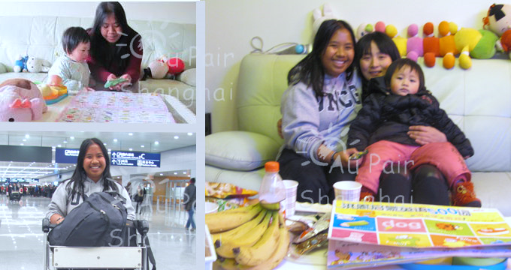

Karissa comes from Australia and lives with a family in Hangzhou. The host mother and grandparents are taking care of a 2-year-old baby, but they want for the baby to live in a foreign language environment.She formed a deep bond with the children of her host family. She practiced Chinese in the most natural way - by using it every day with her Chinese host family.

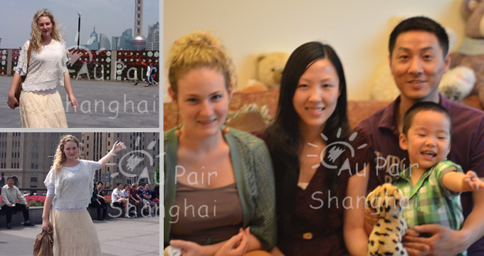

Seychella comes from England and lives with a family in Shanghai. There are two sons in their family; the eldest son is 12 years old and the youngest son is 3 years old.  
She likes the warm, easygoing nature of the Chinese people that she experienced in the daily life of her host family. She attends Chinese classes at a college and makes friends with students all over the world. She sees how other people live, think, and raise their children, and she discovers new things about the life and culture of other people.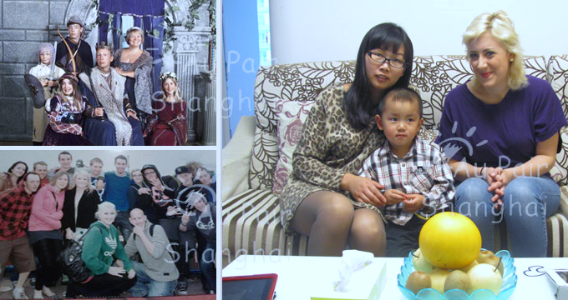VII.

F.A.Q.’s

Q1: If I want to be an au pair in China, but I just apply for 3 months, what kind of visa should I apply for?

A1: Generally, you have to apply for a tourist visa.

Q2: If I apply for more than 3 months, what kind of visa should I apply for?

A2: You can apply for a student visa or a business visa.

Q3: How much pocket money could I get every month?

A3: Currently, most host families will pay 1,500 RMB minimum per month.

Q4: Besides the pocket money, what else could I get?

Q4: You will also get support money for your airline ticket.

Q5: What would I do as an au pair in a Chinese host family?

A5: The main tasks are referred to on the page*au pair work***.**

Q6: How would I take the Chinese classes?

A6: Basically every week, you will have 4 hours of Chinese lessons. Besides the Chinese courses taken from professional mandarin teachers, the host family will also spend one hour to talk with you every day in order to help improve your language skills.

Q7: What’s the main application process?

A7:

* Fill out the application form.
* Communicate via e-mail or Skype.
* Confirm the completion of the application.
* Offer you information about our host families.
* Arrange the suitable time for both parties to talk on Skype.
* Sign the contract.
* Arrangement of schedule in China.
* After your arrival, the host family will pick up you at the airport.
* Au pair’s life in China begins.

Q8: How much flight ticket support am I able to receive?

A8: It depends on how long the au pair stays with the host family. For example, if an au pair stays for 1 year, we will pay 8,000 RMB to the au pair after they finish their whole period of time in China.

Q9: When would I take the Chinese course? When should I apply for the visa? When should I pay for the insurance?

A9: Chinese classes start 1 week after your arrival to the host family’s home. The visa must be applied for before you come to China, and we will help you with the necessary documents in order for you to get your visa.

The insurance fees will be paid by us after your arrival to the host family.

Q10: What does the insurance costs include?

A10: It includes F.P.A., personal accident insurance, hospitalization medical insurance, and personal liability insurance (covers all accidentals).

Contact Us:

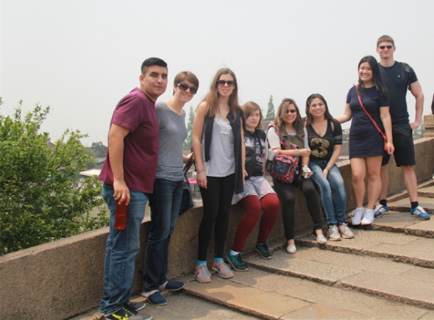**Au Pair Shanghai**

Tel: +86 21 62522006

+86 21 62522012

Fax: +86 21 62522005

Skype: roniyan925/nihaoaupair

Email: [info@aupairshanghai.com](mailto:info@aupairshanghai.com)

<Http://www.nihaoaupair.com>

Our general office Address:

Rm11G, Huamin Empire Plaza, Yan’an West Rd No. 728, Changning District, Shanghai, China.(200050)

We also have offices located in: Guangzhou/Shenzhen/Ningbo/Xi’an/Changsha/Beijing, etc.