Hey future Family,
My name is Jane. I am 22 years old and was born and raised in Florida, USA. Last year, I graduated from Tampa University as an English teacher. I love to be outside, I like to do fitness but not in a Gym more the workout in the nature stuff :) also hiking, running, swimming, surfing and just exploring cities and places I don't know are huge hobbies of mine. I just love to be outside in nature and I think that it is very important to be outside with the kids and show them the beauty of nature. I´m also totally into martial arts simply because it teaches you a lot about yourself and helps you get a not giving up mentality for every aspect of your life. And also because it´s a good thing to be able to protect yourself and others.
I became a chef because I was pretty obese when I was younger. So I wanted to learn how to prepare all kind of dishes. But also I wanted to know how I can cook them in a healthy but also tasty way. So that people could eat tasty and healthy food at the same time. Which I did and that helped me to lose around 35kg of weight on my own. Nowadays, I don't work as a professional Chef anymore, not cause I don't like to cook anymore in fact I still love it but the work hours/payment gap is way too huge in my eyes.
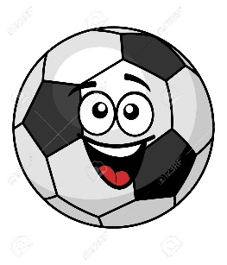
I also wanted to know the Body and Sports and I learned how important it is to move more. Which brought me to another job where I worked as a Camp Counselor in a Summer camp for a Year, Kids Ski instructor in the Winter season for 1 year, 3 months at a kindergarten and now as an Au Pair I took care of a 3-year-old boy and his 5-year-old special-needs brother. In all the Jobs I worked with Kids groups from 2 to14 Kids and just 1 or 2 kids at the same time and an age range from 3 to 14 years. I played a lot of Sport with them, did a lot of sports with them of course :D. I cooked for them and helped them with any possible ´´problems´´ they had.
That's also why I want the be/ am an Au pair now. Because I found a fulfilling job in working with kids I simply found my passion in it. They are just so thankful, honest, simply happy, and loving. I find heartwarming but sadly it is something that we lose more and more in our society nowadays but that shouldn't be like that.
So if you would like someone to take care of your kids who loves to cook healthy (and of course sometimes unhealthy cause life is too short to say no to all the good Sins that some food is), to move and be outside with the little ones or big ones depends on the age of your children ;) and help you raise them to love and living individuals and not display gazing, non caring persons then I hope I can be an enrichment to your family which I'm sure I can be.
Because That is mention and also important, my Driving skills are very good I drive nearly daily since I have my driving license (6 years) also driving on snow is no problem for me because the town where I come from is a Skiing area in the Mountains.
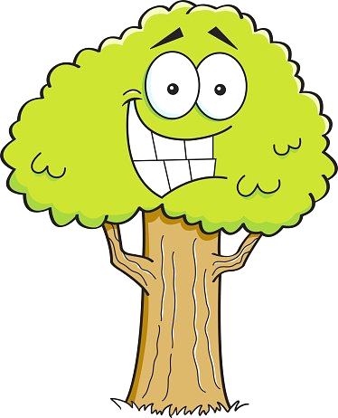
So now straight to your kids, it would be a total pleasure for me to take care of you see your grow and do a lot of awesome stuff with you. I would be more than open to check out your hobbies and learn something from you too.
For the little princesses, In the summer camp, I had the dance group/class and besides that also the baking class was under my lead. Just if you are also into eating sweet things :) I would love to teach you that too if you little ladies would like to. P
.s. I´m also a huge fan of Unicorns because they are so super majestic and simply awesome!! :D
for the little big boys, like I already said I´m a huge fan of martial arts and if you are also into it or maybe want to try one time it would be a more then pleasure for me to try it out with you and of course I would love to try out your Hobbies with you too. But I also like to play some PlayStation from time to time, I would be in with that too. And also no matter which age you are I will be there to help you with all the boys' problems that will come up as good as I can.
For me, it´s very important that kids nowadays in times of the Smartphones and IPad Generation to teach and learn the Kids how to Keep themselves busy and entertained without that stuff too. Just because sadly but truly we start forgetting to understand and be aware of the Beauty of nature and alive without Technology from time to time. I hope I can give your children a small piece of that understanding for their lives and with that a great childhood. It would be a pleasure for me to live with you and help you with your children, see them grow and hopefully let them have such a great childhood that I had. But also, on the other hand, learn as much, form them and you in every aspect of life, as I can So if you and your family would love to have an Au pair that thinks this way, I would love to join your Family.
So I hope that "small" Letter will give you a little insight into my personality and caught your attention for me.
So Kids if you think that I sound like somebody you want to have around and to a lot of funny stuff with, help me to convince your parents and bring them to skype with me and convince them to have me around you as your Au pair.
I hope to hear from you very soon.
Love,
Jane, swimmer, outdoor enthusiast, and chef

